**Handover Document – MediaWiki Install**

**NASA EVA Gamification**

*Group 3*

**Prepared By**

Michael Salgo

Victoria Guadagno

Okechukwu Ogudebe

Jacqueline Macfadyen

Kevin Fortier

Montrell Nuble

Contents

Introduction 3

Document Overview 3

Software Architecture Overview 3

|  |  |  |  |
| --- | --- | --- | --- |
| **Version Number** | **Description of Change** | **Author** | **Date** |
| 1.0 | Initial Creation of Document | Michael Salgo | 03/17/2018 |

# Introduction

## Document Overview

This document will detail the steps needed to get MediaWiki up and running on a Windows- or CentOS- based environment. For the CentOS install, there is an installation package called Meza which includes all of the necessary subcomponents including MariaDB, PHP, Apache, and MediaWiki itself. The GitHub repository for the Meza installation package can be found here: <https://github.com/enterprisemediawiki/meza>.

# Operating System

## Windows

If using a Windows-based installation, use Windows 7 or higher, 64-bit or 32-bit.

## CentOS

If using a CentOS-based installation, use CentOS7.

# Web Browser

## Windows

If using a Windows-based installation, install the latest version of Mozilla Firefox or Google Chrome.

### Firefox

The latest version of the Mozilla Firefox web browser can be found here: <https://www.mozilla.org/en-US/firefox/>.

### Chrome

The latest version of the Google Chrome web browser can be found here: <https://www.google.com/intl/en/chrome/>.

## CentOS

If using a CentOS-based installation, no graphical user interface will be available and thus interactions will be command line driven.

# MariaDB/MySQL

Either of these two databases are supported by MediaWiki. The version to install, as dictated by the Meza installer, is 5.5 for both MariaDB and MySQL.

## Windows

### MariaDB

The latest version of MariaDB can be found here: <https://downloads.mariadb.org/mariadb/>. Scroll down the page and look for “MariaDB 5.5 Series” – beneath this section there will be a “Download 5.5.[latest version number] Stable” button where [latest version number] will be the number of the latest version. At the time of this writing, the latest version is 5.5.59.

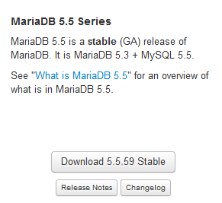

After clicking on the Download button, you will be brought to a download page, such as <https://downloads.mariadb.org/mariadb/5.5.59/>. Download either the 64- or 32-bit version for either the Windows x86_64 or the Windows x86 OS / CPU, respectively. Clicking on the “Windows” checkbox on the right-hand side under “Operating System” will help reduce the choices on the screen, making it easier to determine which file to download. The recommended choice is to download the MSI file as it requires less bandwidth and does not have to be unzipped once downloaded.

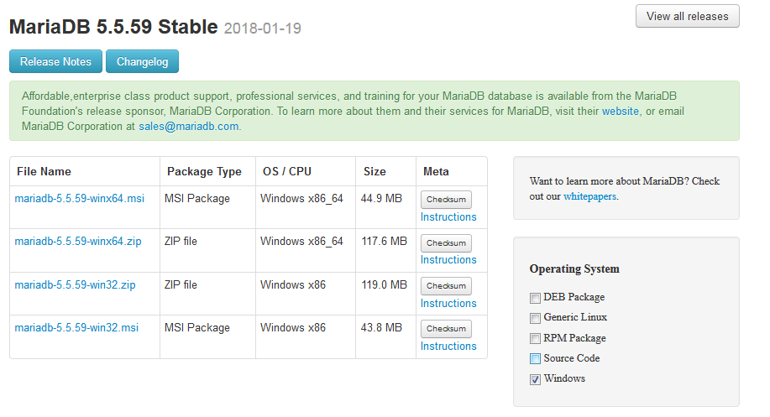

Once downloaded, double-click the .msi file to start the install. Click “Run” if a security warning dialogue appears.

Start the install by clicking “Next.”

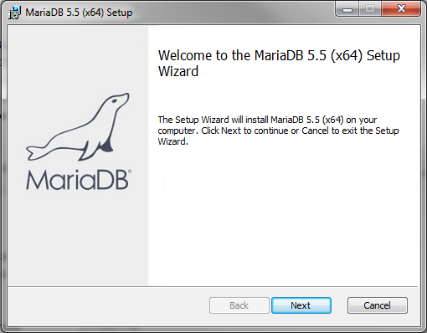

Click on the “I accept the terms in the License Agreement” checkbox and click on “Next.”

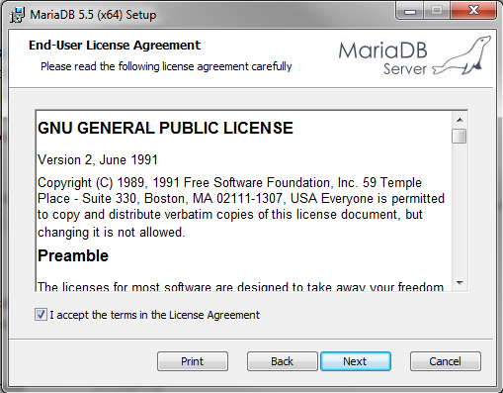

Leave every setting as is, unless you want to change the location of the install, and click on “Next.”

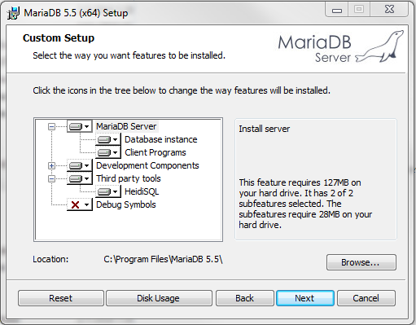

Type in a new root password for yourself and again in the “Confirm:” textbox – leave all other options as is and click on “Next.”

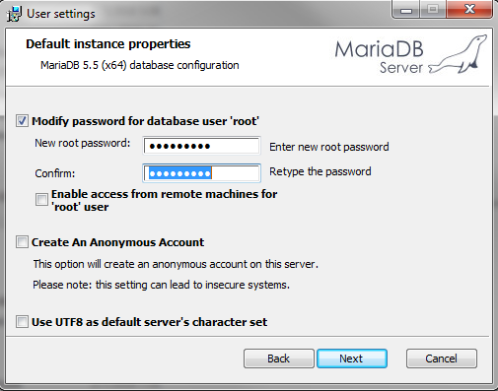

Leave everything as is and click on “Next.”

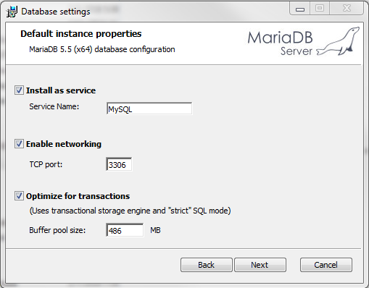

Leave everything as is and click on “Next.”

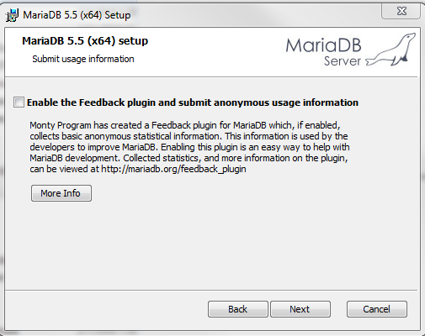

Click on “Install.”

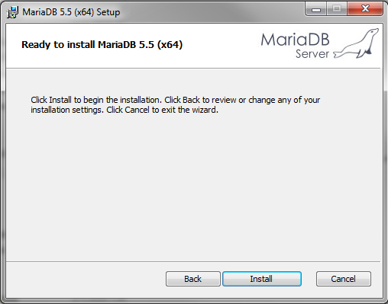

Click on “Finish.”

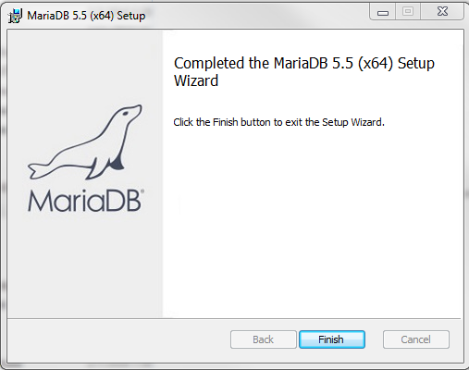

### MySQL

** Installation steps for MySQL under Windows are not presently documented **

## CentOS

MariaDB comes pre-installed with the Meza package installation.

# HTTP Server

## Windows

### IIS

** Installation steps for IIS under Windows are not presently documented **

### IIS Express

The easiest way to install IIS Express will be to first install the Microsoft Web Platform Installer (WPI). Read and follow the steps to download the WPI below to be able to easily install IIS Express on your Windows computer. Come back to this section for the next steps thereafter.

Go to Start 🡪 All Programs and look for and click on “Microsoft Web Platform Installer.”

Once WPI loads, type in “IIS Express” in the search bar on the top right and press Enter on your keyboard.

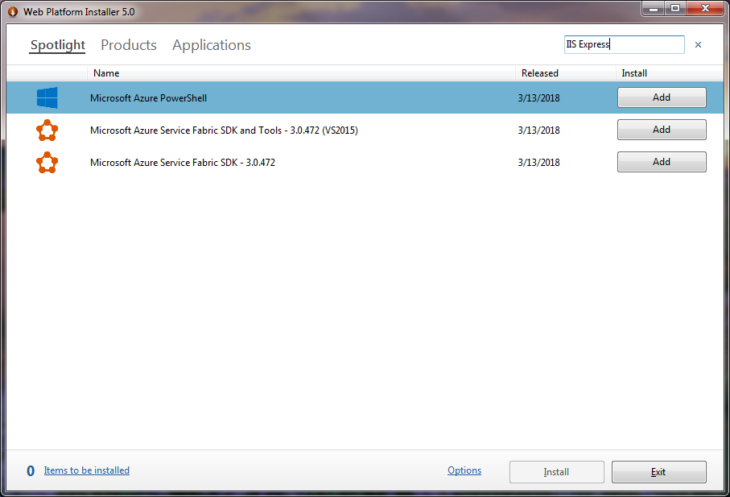

Click on the “Name” column header to sort the list by name.

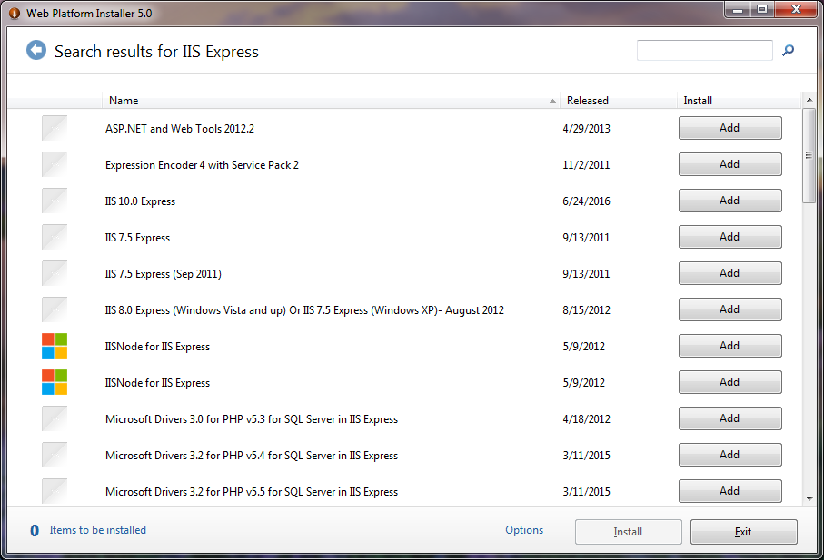

Click on the “Add” button next to either the IIS 10.0 Express, IIS 7.5 Express (either option) or the IIS 8.0 Express. It is recommended to use the IIS 8.0 Express version as it is more proven than the 7.5 version and more well-documented than the 10.0 version.

Click “Install” on the bottom right to start the IIS 8.0 Express installation.

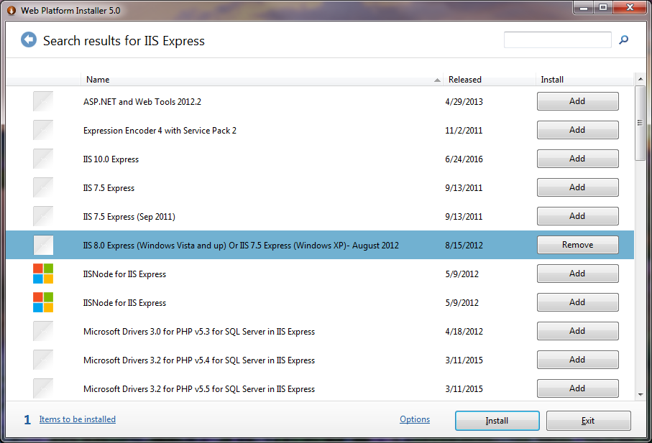

Click “I Accept” on the bottom right to accept the Microsoft license terms.

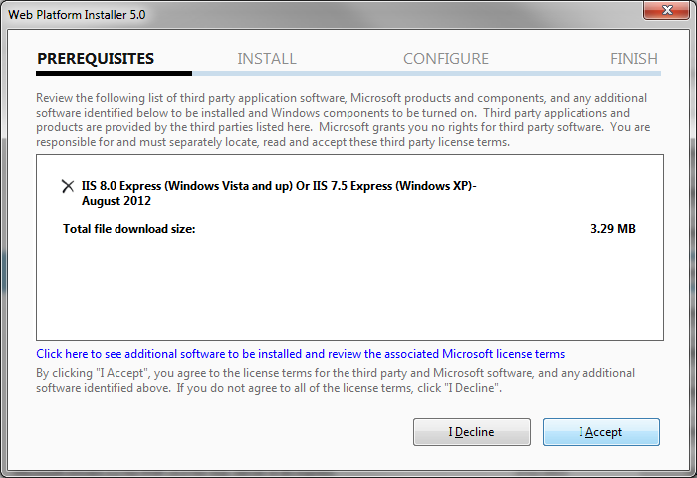

Click on “Finish” to complete the installation.

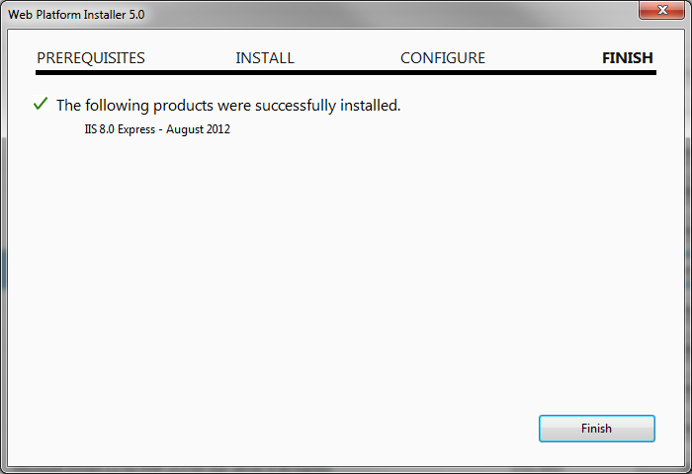

### Microsoft Web Platform Installer

At the time of this writing, the latest version is 5.0. Microsoft Web Platform Installer (WPI) can be obtained by going to <https://www.microsoft.com/web/downloads/platform.aspx>. Once on this website, click on “Install this extension.” If a dialogue prompt appears to open or save the file, save it.

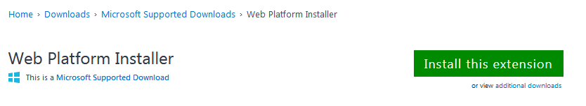

Once downloaded, double-click the .msi file to start the install. Click “Run” if a security warning dialogue appears.

Start the install by clicking the “I accept the terms in the License Agreement” checkbox and clicking on “Install.”

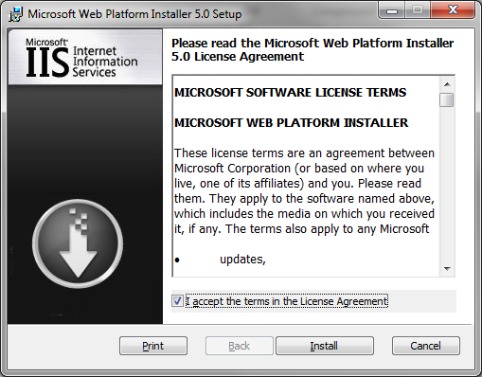

Click on “Finish” to complete the installation.

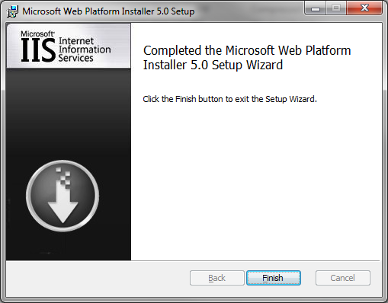

Return to the Windows-based IIS Express install instructions above.

## CentOS

### Apache

Apache comes pre-installed with the Meza package installation.

# PHP

PHP is a platform free coding language which is the language used by MediaWiki. The Meza package installs version 5.6 of PHP.

## Windows

The latest version of PHP 5.6 at the time of this writing is 5.6.31. The easiest way to install PHP on Windows is to use the Web Platform Installer (WPI).

### IIS

** Installation steps for IIS under Windows are not presently documented **

### IIS Express

Go to Start 🡪 All Programs and look for and click on “Microsoft Web Platform Installer.”

Once WPI loads, type in “PHP IIS Express” in the search bar on the top right and press Enter on your keyboard.

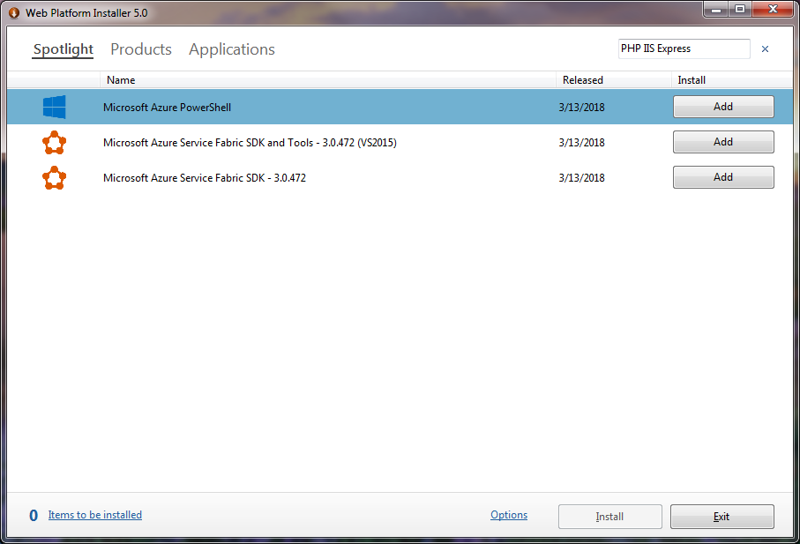

Click on the “Name” column header to sort the list by name.

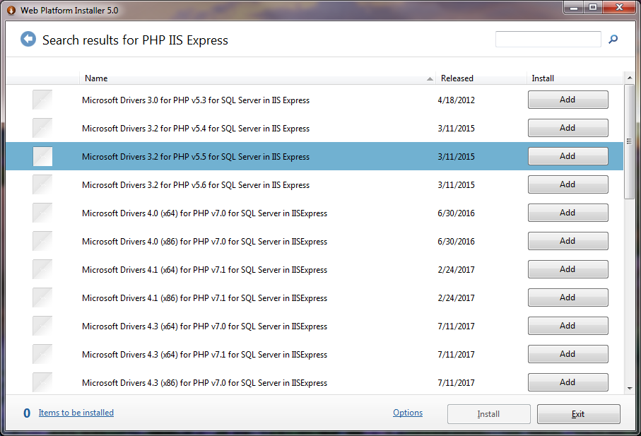

Scroll down and click on the “Add” button next to “PHP 5.6.[latest version number] IIS Express” where the [latest version number] will be the latest version available.

Click “Install” on the bottom right to start the PHP for IIS Express installation.

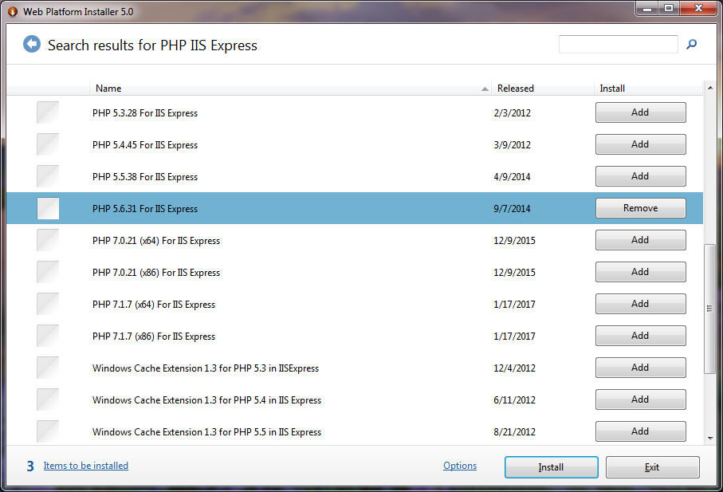

Click “I Accept” on the bottom right to accept the Microsoft license terms.

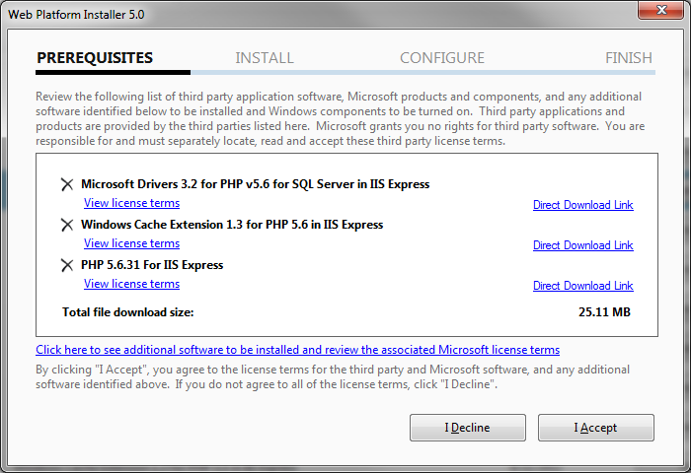

Click on “Finish” to complete the installation.

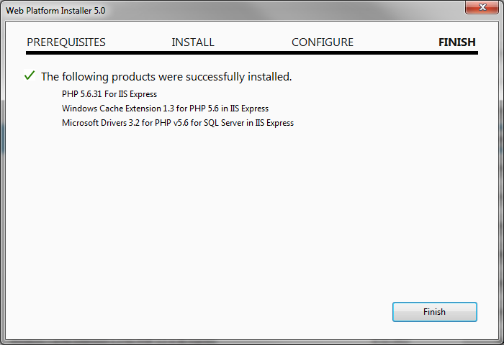

## CentOS

PHP comes pre-installed with the Meza package installation.

# MediaWiki

MediaWiki is an open source wiki platform which is the foundation for this project. The Meza package installs version 1.27 of MediaWiki.

## Windows

The latest version of MediaWiki 1.27 can be found here: <https://www.mediawiki.org/wiki/Download>. Locate the “download” link for MediaWiki 1.27.[latest version number] where [latest version number] will be the number of the latest version. At the time of this writing, the latest version is 1.27.4.

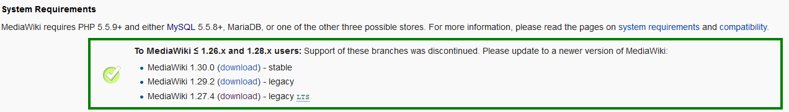

This will download a .tar.gz file which needs to be double unzipped in order to get to the files needed. Windows does not come with a way to unzip .tar.gz files so a third party program will need to be installed. Read and follow the steps to download 7-Zip, a free unzipping utility, below to be able to unzip the contents of this download file. Come back to this section for the next steps thereafter.

Right-click the downloaded .tar.gz file, hover over “7-Zip,” and click on “Extract Here.” This will create a .tar file which itself needs to be unzipped.

Right-click the unzipped .tar file, hover over “7-Zip,” and click on “Extract Here.” This will take a minute or so to unzip as there are a lot of files in this folder.

Place this folder (or a copy of this folder) somewhere convenient as it will be used very frequently when viewing or modifying the MediaWiki. This folder will be referred to as the MediaWiki folder in steps below.

Hold the Shift key on your keyboard and right-click on the MediaWiki folder and click “Open command window here.” This will open up a command prompt at this folder path to save time of having to manually open up the command prompt and change the directory to the needed folder path.

Start IIS or IIS Express by following the steps below to be able to access these files within the MediaWiki folder like a web site. Come back to this section for the next steps thereafter.

Open up your web browser (Chrome or Firefox) and go to <http://localhost:8080/>. A default home page will appear. Click on the “set up the wiki” link.

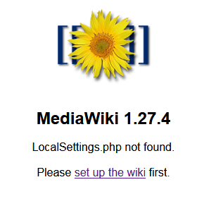

This will take you to the <http://localhost:8080/mw-config/index.php> page. Click on “Continue 🡪” or change your language if desired.

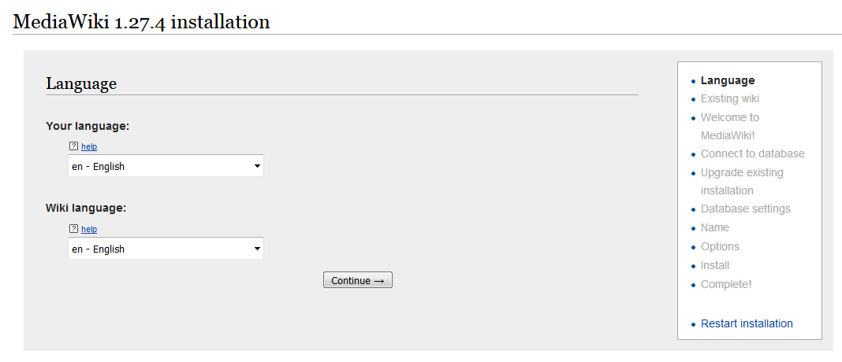

Scroll down to the bottom of the page and click on “Continue 🡪.”

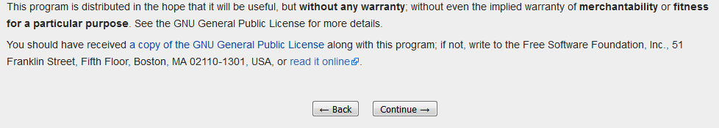

Leave “Database type:” as “MySQL (or compatible)” as the “or compatible” references MariaDB. Leave all other information as is, type in a “Database password:,” and click on “Continue 🡪.” You can use the same password as your MariaDB install if desired.

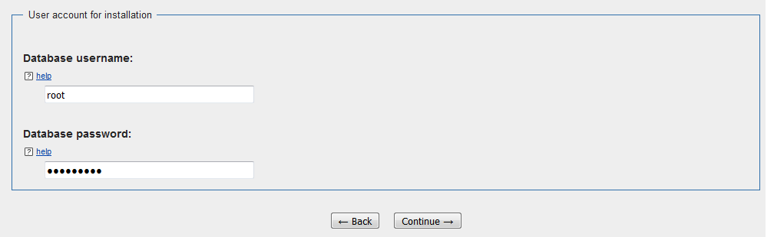

Leave “Storage engine:” as InnoDB and change “Database character set:” to UTF-8 as these settings mimic what is installed with the Meza install. Click on “Continue 🡪.”

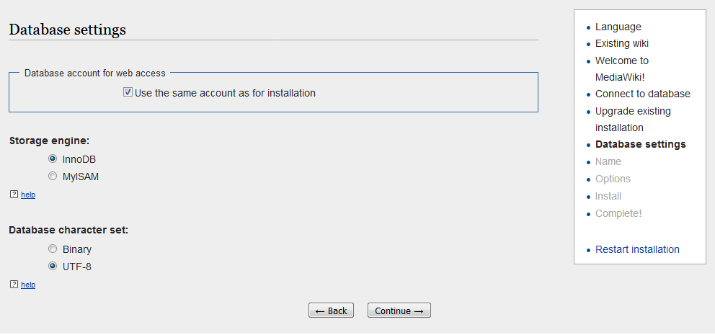

Give your Wiki a name such as “My Wiki,” type in a username and password for yourself, and leave all other settings as is (including “Email address:” and click “Continue 🡪” at the bottom of the page. You can use the same password as your MariaDB install if desired.

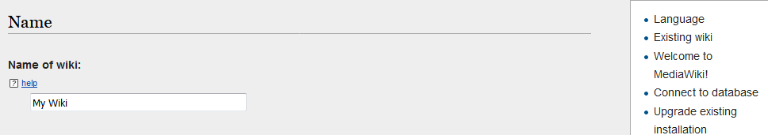

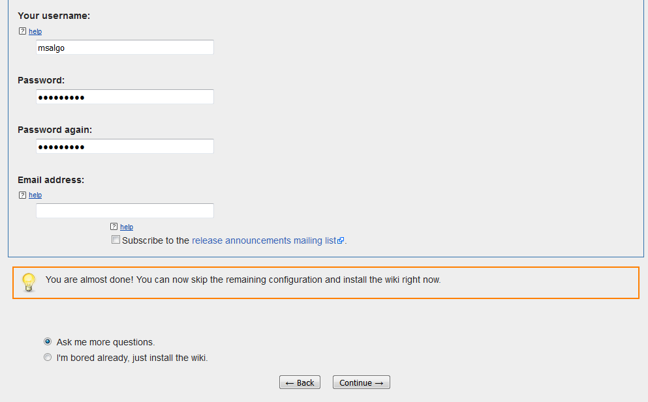

Leave all settings as is and scroll down to the bottom of the page and click on “Continue 🡪.” Some extensions may be enabled from here for future use, but for now at the time of this writing, no extensions are needed.

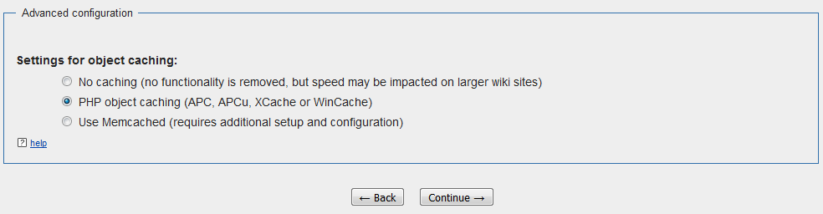

Click on “Continue 🡪.”

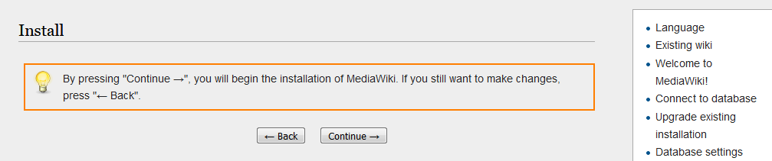

Click on “Continue 🡪.”

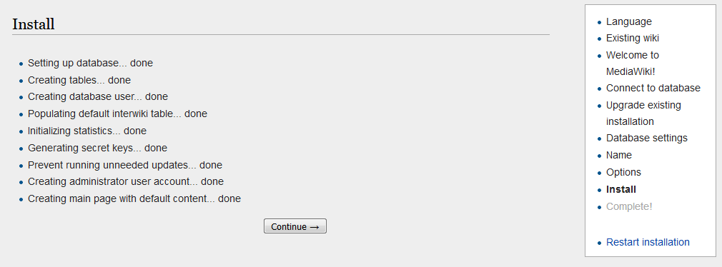

A dialogue will appear with an option to open or save a LocalSettings.php file. Save this file in the MediaWiki folder at the root level or save it somewhere else first and move it to the MediaWiki folder thereafter.

Copy the following contents to the end of the LocalSettings.php file:

wfLoadExtension( 'NASA_EVA_Gamification' );

$wgShowDebug = true;

$wgDebugComments = true;

$wgEnableParserCache = false;

$wgCachePages = false;

This code will load the code for the NASA_EVA_Gamification extension as well as enable debug information for debugging code and observing behind-the-scenes MediaWiki processes.

Save changes to the file.

### 7-Zip

The latest version of 7-Zip can be found here: <https://www.7-zip.org/>. Click on “Download” for either the 64- or 32-bit Windows version as needed.

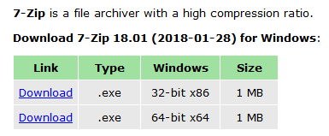

Once downloaded, double-click the.exe file to start the install. Click “Run” if a security warning dialogue appears.

Click “Install” or change your folder destination first if required.

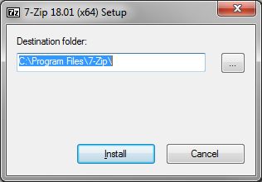

Click “Close.”

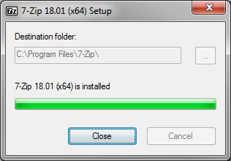

Return to the Windows-based MediaWiki install instructions above.

### IIS

** Installation steps for IIS under Windows are not presently documented **

### IIS Express

Type in “runphp.cmd” and hit enter on your keyboard. This will start IIS Express which will allow for the contents of the MediaWiki folder to act as a web site under <http://localhost:8080/>.

Return to the Windows-based MediaWiki install instructions above.

## CentOS

MediaWiki comes pre-installed with the Meza package installation.

# NAVA_EVA_Gamification Extension

## Windows

Copy all of the files in the team’s GitHub repository (located in the “NASA_EVA_Gamification” repository for the Spring 2018 Semester). Double-click the “extensions” folder in the MediaWiki folder and create a new folder called “NASA_EVA_Gamification” – thereafter, paste the files copied before.

Go back to the MediaWiki folder, hold the Shift key on your keyboard, and right-click on the maintenance folder and click “Open command window here.” This will open up a command prompt at this folder path to save time of having to manually open up the command prompt and change the directory to the needed folder path.

Type in “php update.php” and hit enter on your keyboard. This will do an update of MediaWiki which will have all of the code from the NASA_EVA_Gamification extension get installed. This process will take several minutes. Close out the command prompt window once this process is complete.

## CentOS

** Directions for CentOS need to be added still [Kevin] **

# SMTP Server

For testing our some of the games, an email may need to be sent out from MediaWiki. Because not all systems of installation will have a public-facing SMTP server or a private SMTP server set up, a way to receive emails locally will need to be set up.

## Windows

On the Windows OS, a useful and free program to allow for localhost SMTP traffic is called Papercut. It is recommended to install the latest version of this software.

### Papercut

The latest version of Papercut can be found here: <https://github.com/ChangemakerStudios/Papercut/releases>. Click on “Papercut.Setup.exe” to download this program. The latest version of this software at the time of writing is 5.1.23.

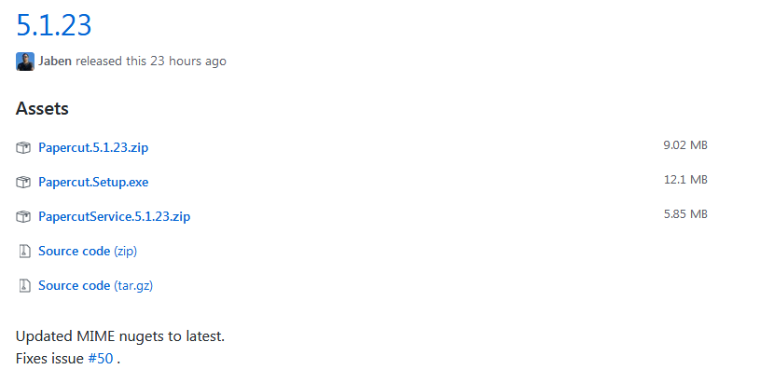

Once downloaded, double-click the Papercut.Setup.exe file to start the install. Click “Run” if a security warning dialogue appears.

Click on “Install” or click on “Options” first to change the installation path if desired.

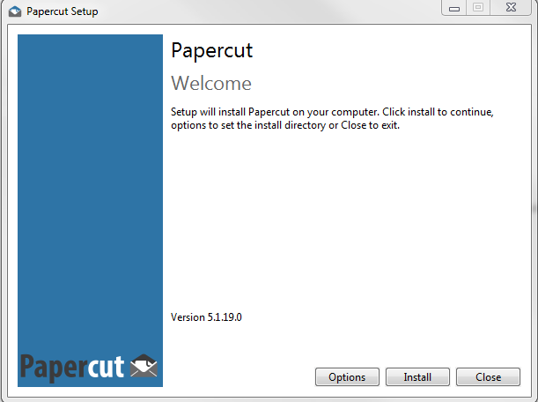

A pop-up dialogue will appear, click on “Next.”

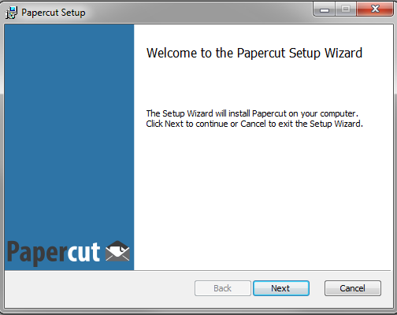

Leave everything as is and click on “Next.”

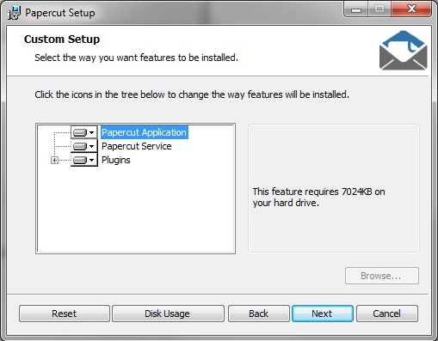

Click on “Install.”

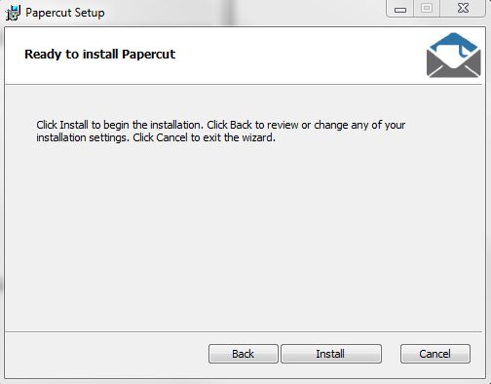

Click on “Finish.”

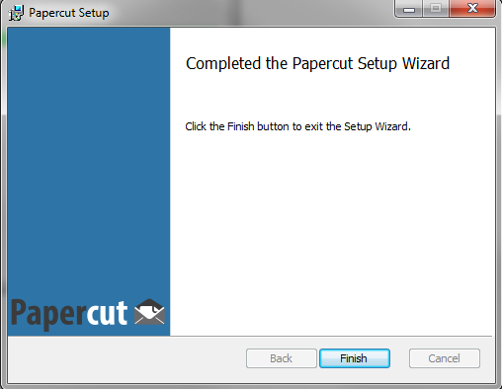

Click on “Close.”

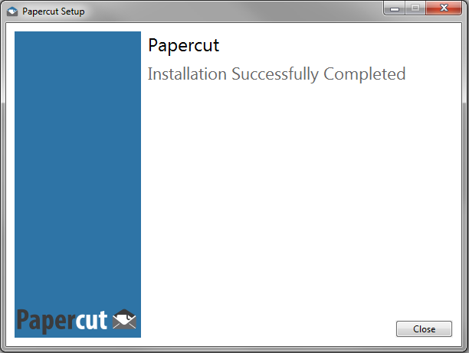

## CentOS

** Directions for CentOS need to be added still [Kevin] **